**MRO CRISM Type Spectra Library**

I believe this site provides us with laboratory spectral data for minerals based on the same wavelengths as what we get from CRISM <https://crismtypespectra.rsl.wustl.edu/>.

The problem is, the MTRDR data we use from CRISM has summary products, not the raw wavelength data, so what we need to do is:

* Replicate how the summary products in the Mars MTRDR data come about and verify our calculations; and
* Apply the same math to the raw spectral data in the MRO CRISM Type Spectra Library.
* If we do that, we then have a like for like comparison between what signatures these minerals have in a lab compared to that in mars.

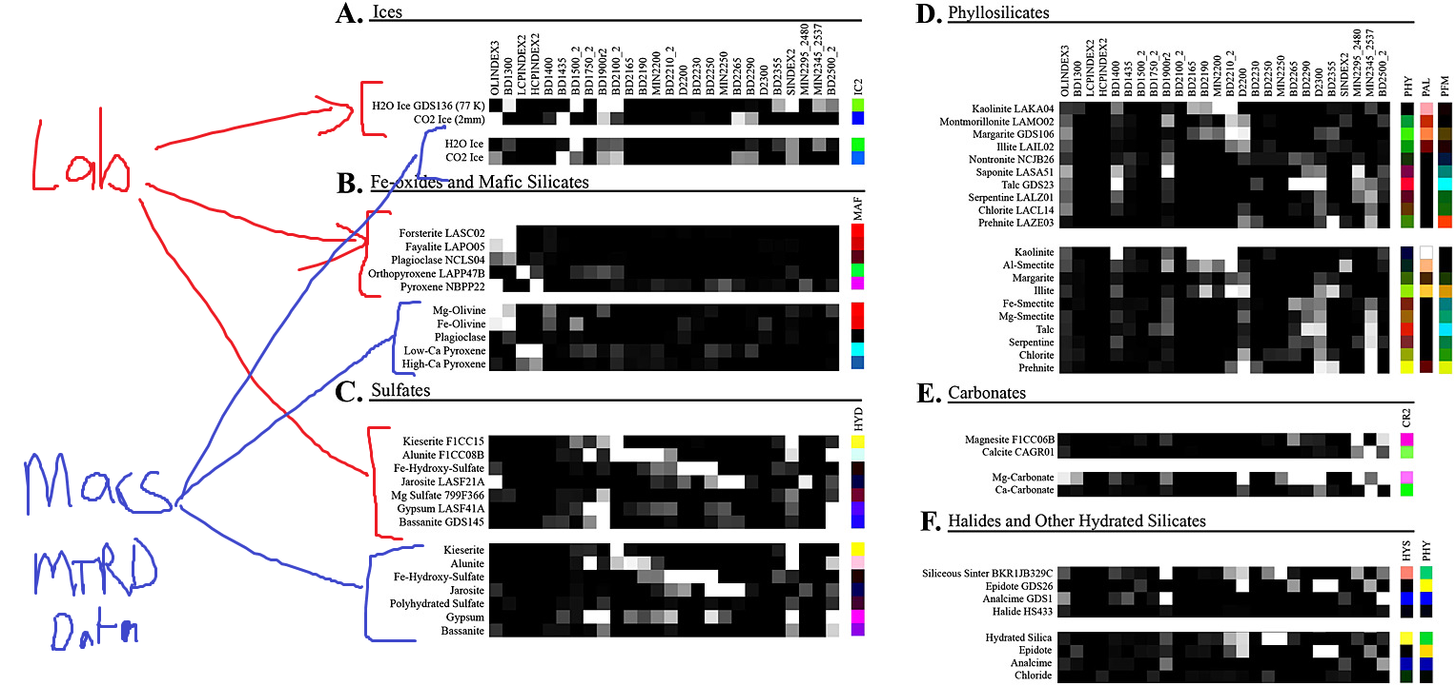

To transform the MRO CRISM Type Spectra Library data to the same summary products we see in MTRDR data, we need to apply all this math here:

* Table 2 - <https://agupubs.onlinelibrary.wiley.com/doi/full/10.1002/2014JE004627>

Note like this:  
  
In this calculation the R530 is simply not the spectral value of the wave length at 530, it is calculated as R530:5 which means you take the spectral data from the 5 nearest wavelengths and it is the median value at those 5 wavelengths that becomes R530.  
  
Information on this “kernel width” calculation is found in section 4.5 here - <https://agupubs.onlinelibrary.wiley.com/doi/full/10.1002/2014JE004627>

My plan is to use raw spectral data from CRISM to find the exact wavelengths that were used to generate the summary products in the CRISM MTRDR data and then use the same wavelengths or as close to from the MRO CRISM Type Spectra Library to generate like-like summary products from the lab data.  
  
There are also many other difficult calculations that need to be done here such as this (which I don’t know what it entails yet):



THE POINT HERE – is to transfer the raw lab spectral data into the same format/products as what we obtain from MTRDR data in CRISM so we can marry the two together.